 | Halloween House Party  Friday October 31, 2008 7:30 PM - 10:00 +  Delta Zeta House - 806 North 4th Street, Fairfield Iowa  Across the Street from Maharishi University of Management | 

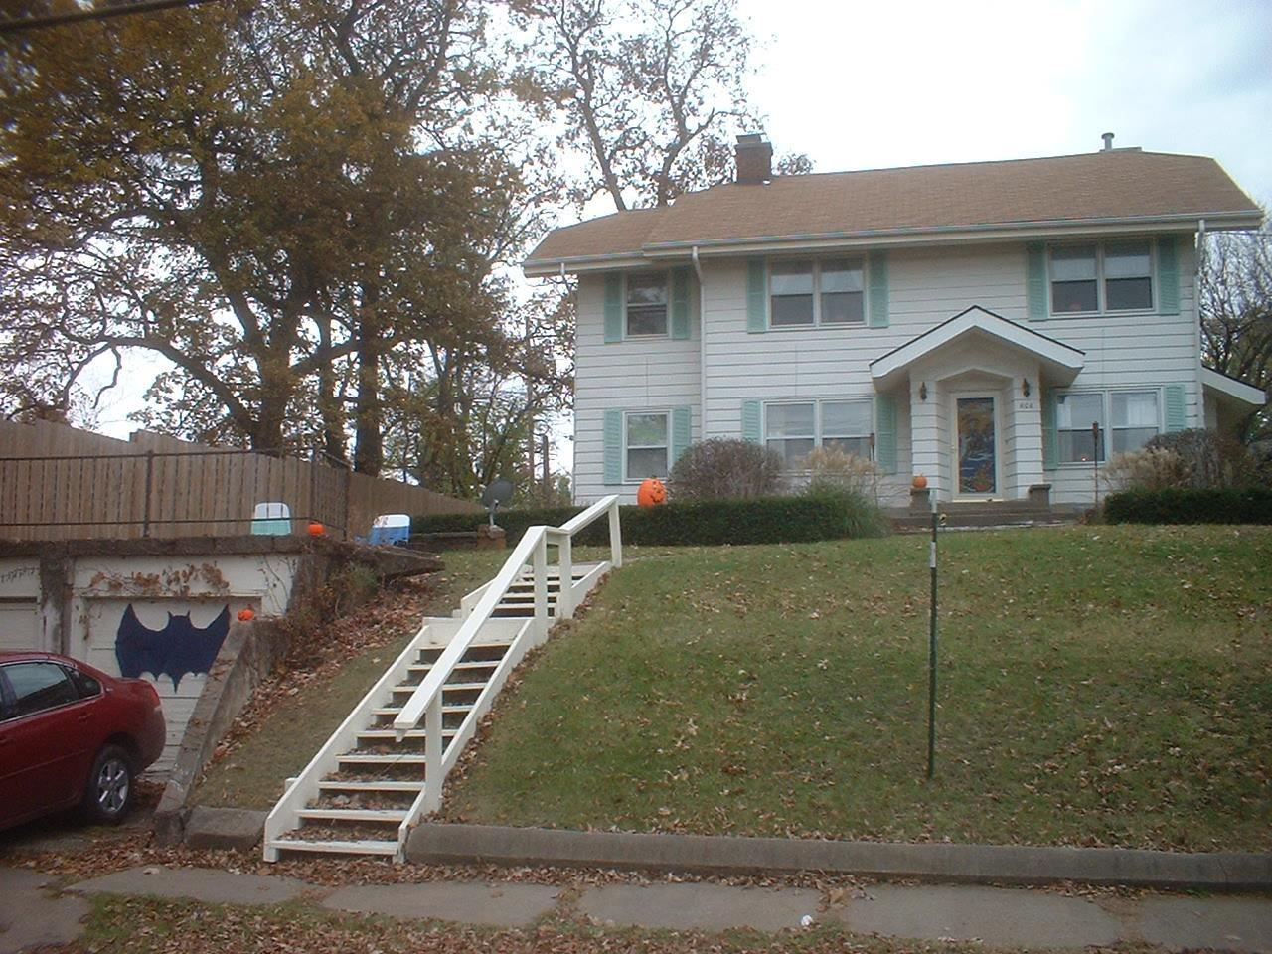 | 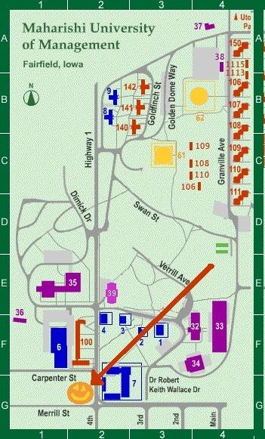

FREE Admission, Food and Drink. Dancing. Costumes encouraged
www.DeltaZetaHouse.com/Halloween

Halloween House Party
Friday October 31, 2008 7:30 PM - 10:00 +
Delta Zeta House - 806 North 4th Street, Fairfield Iowa
Across the Street from Maharishi University of Management
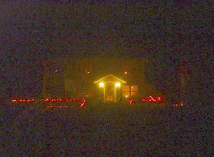

FREE Admission, Food and Drink. Dancing. Costumes encouraged
www.DeltaZetaHouse.com/Halloween

